1. Make this date say “2020-03-01” to match the SUP info modal.

Should be fine that the other “Activation” timestamps are pulling the current date and time.

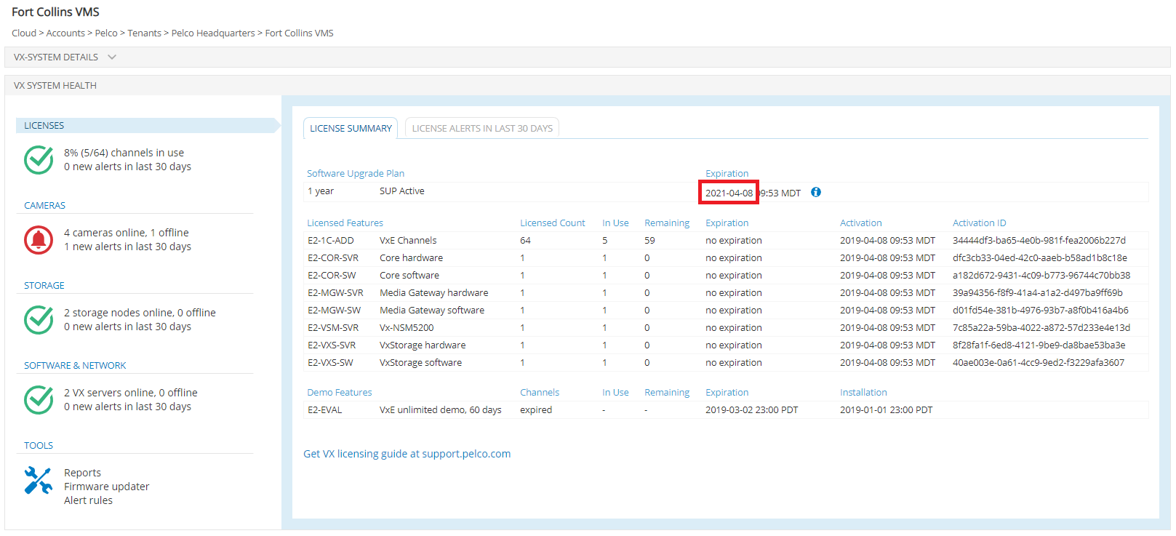

1. There is funny vertical alignment in this cell – think we got out of sync on the css classes applied to this info link.

The <a> tag should have class=“highlight-clickable-icon after-text”.

The <img> should have no css classes applied to it.

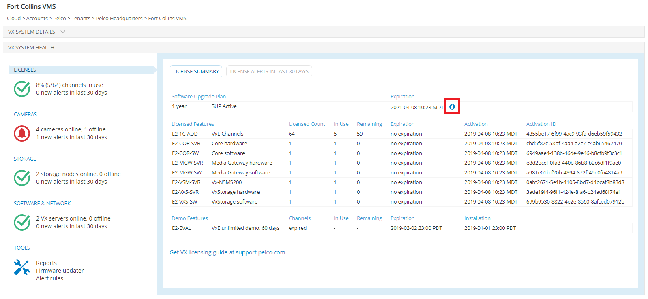

1. Similar to previous item:

The <a> tag should have class=“highlight-clickable-icon after-text”.

The <img> should have no css classes applied to it.

Also, the <a> tag should have title=“Additional info at support.pelco.com”, and clicking it should open external page https://support.pelco.com in target=“_blank”.

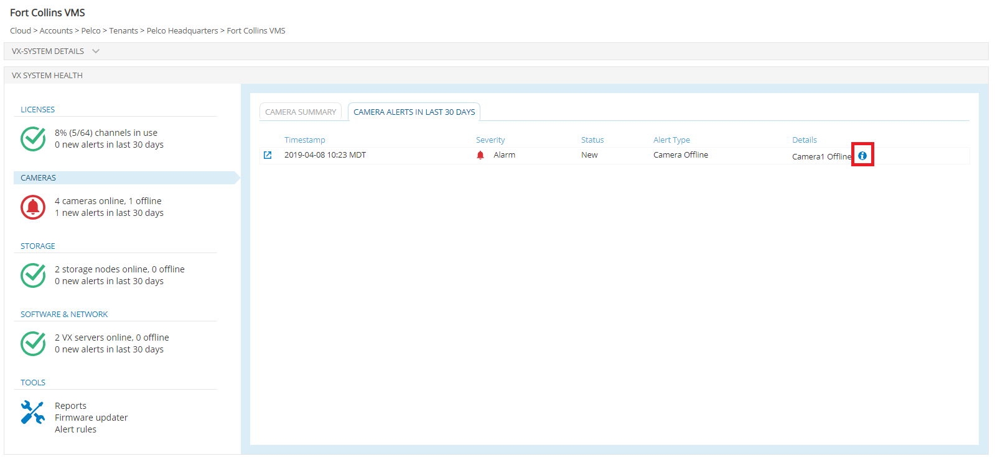

1. Is it easy either to purge the camera offline/online history periodically and/or make it go offline/online less frequently? Like, maybe purge it once a day and make it go online/offline every 12-15 mins or so? No biggie. Only if easy to do. Otherwise it is fine the way it is.
2. Looks like the custom scrollbar styles aren’t showing up. Looks like an @import line needs to be added to styles.less for @import '../less/elements/scrollbars.less'. Let me know if this was omitted on purpose. I realize these are non-standard styles but do work in Chrome, which is what everyone uses, right? :)

If you guys prefer not to use these non-standard styles, let me know whether:  
a) you prefer not to override the default browser scrollbar at all, or   
b) if an Angular scrollbar customization is preferred.

Based on what you guys prefer, I can rethink how the various flexboxes should scroll.

This is not a biggie for the ISC demo. I thought, if it’s a quick fix, hey let’s throw it in. If not, we can discuss more after ISC.

1. These two tables are missing either <td>s or a colspan=”” attribute on the last <td>.

